POWERS AND ROOTS
Pearson Edexcel - Tuesday 19 May 2020 - Paper 1 (Non-Calculator) Higher Tier
1.
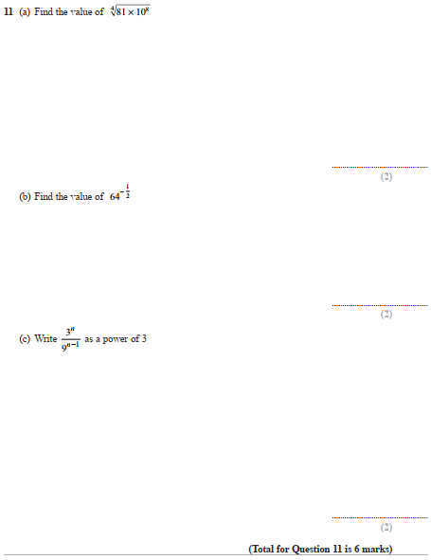

Pearson Edexcel - Tuesday 11 June 2019 - Paper 3 (Calculator) Higher Tier
2.

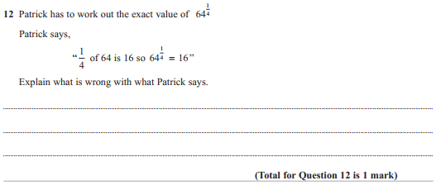
Pearson Edexcel - Tuesday 6 November 2018 - Paper 1 (Non-Calculator) Higher Tier
3.
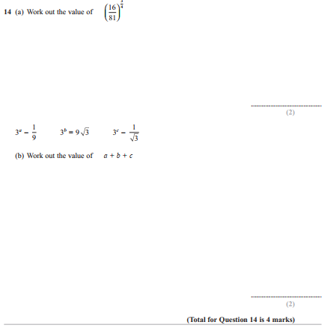
Pearson Edexcel - Thursday 24 May 2018 - Paper 1 (Non-Calculator) Higher Tier
4.
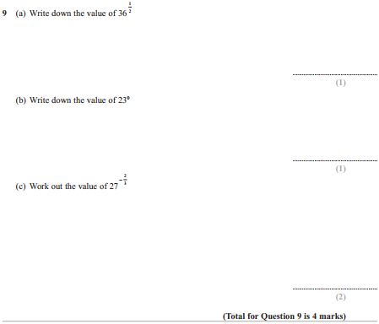
Pearson Edexcel - Thursday 24 May 2018 - Paper 1 (Non-Calculator) Higher Tier
5.
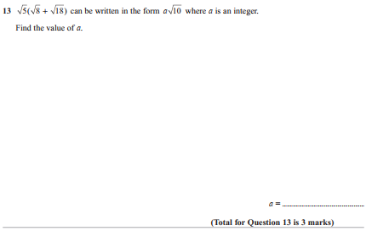

Pearson Edexcel - Thursday 2 November 2017 - Paper 1 (Non-Calculator) Higher Tier
6.
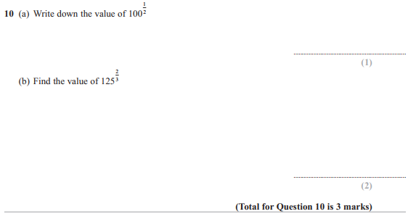
Pearson Edexcel - Thursday 25 May 2017 - Paper 1 (Non-Calculator) Higher Tier
7.
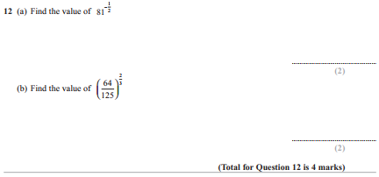

Pearson Edexcel - Specimen Papers Set 2 - Paper 2 (Calculator) Higher Tier
8.
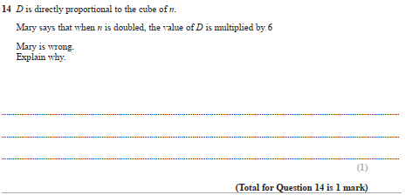
Pearson Edexcel - Specimen Papers Set 2 - Paper 2 (Calculator) Higher Tier
9.
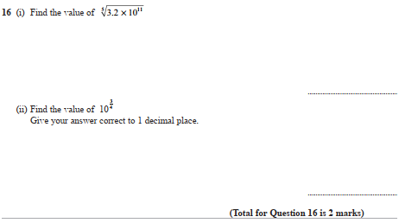
Pearson Edexcel - Specimen Papers Set 1 - Paper 1 (Non-Calculator) Higher Tier
10.
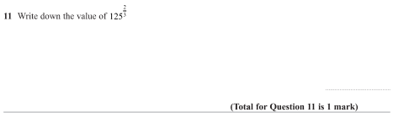
Pearson Edexcel - Wednesday 9 November 2011 - Paper 3 (Non-Calculator) Higher Tier
11.
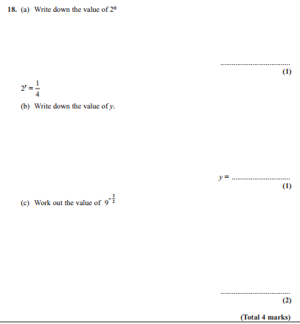

Pearson Edexcel - Monday 7 June 2010 - Paper 3 (Non-Calculator) Higher Tier
12.
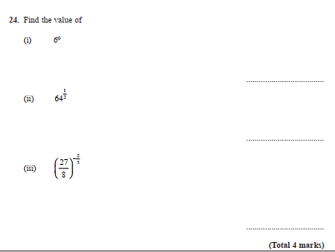

Pearson Edexcel - Thursday 5 November 2009 - Paper 3 (Non-Calculator) Higher Tier
13.
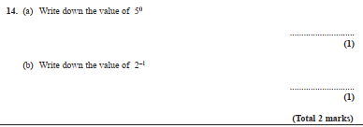
OCR GSCE – Thursday 5 November 2020 – Paper 5 (Non-Calculator) Higher Tier
14.
OCR GSCE – Tuesday 6 November 2017 – Paper 5 (Non - Calculator) Higher Tier
15.
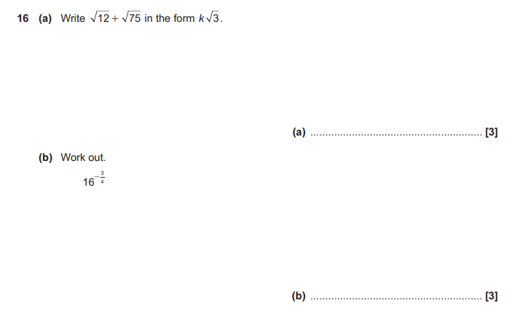

OCR GSCE – Thursday 25 May 2017 – Paper 4 (Calculator) Higher Tier
16.
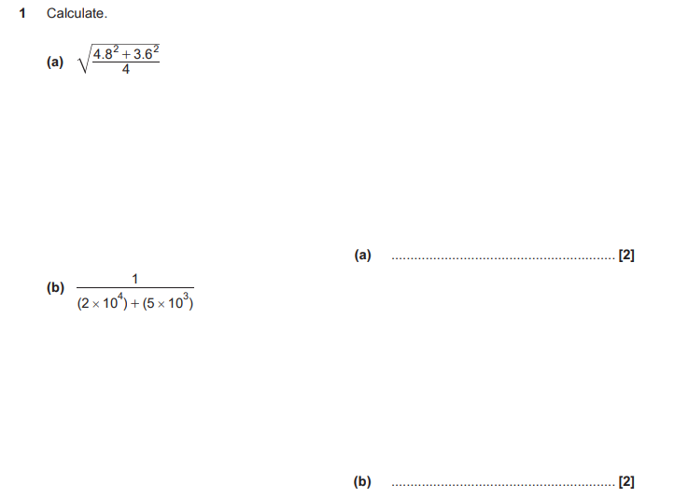
OCR GSCE – Tuesday 13 June 2017 – Paper 6 (Calculator) Higher Tier
17.

OCR GSCE – Sample Papers – Paper 6 (Calculator) Higher Tier
18.
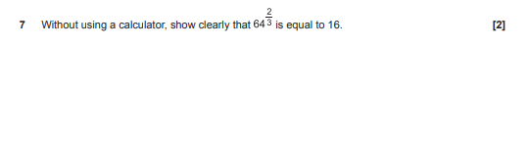
AQA GSCE – Tuesday 19 May 2020 – Paper 1 (Non - Calculator) Higher Tier
19.
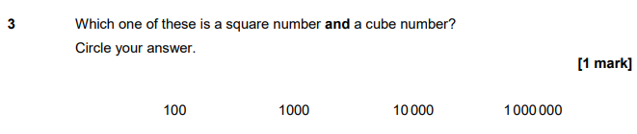

AQA GSCE – Tuesday 19 May 2020 – Paper 1 (Non - Calculator) Higher Tier
20.

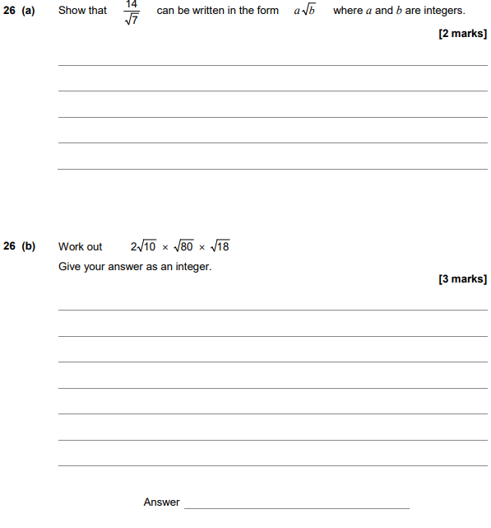

AQA GSCE – Tuesday 21 May 2019 – Paper 1 (Non - Calculator) Higher Tier
21.
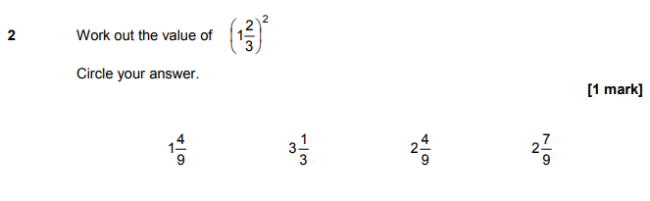
AQA GSCE – Thursday 6 June 2019 – Paper 2 (Calculator) Higher Tier
22.
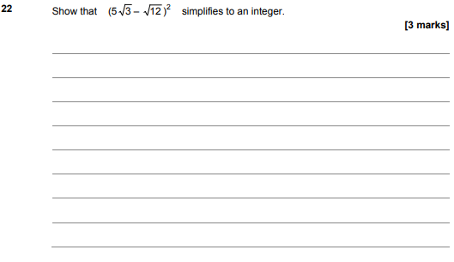

AQA GSCE – Tuesday 6 November 2018 – Paper 1 (Non - Calculator) Higher Tier
23.
AQA GSCE – Tuesday 6 November 2018 – Paper 1 (Non - Calculator) Higher Tier
24.
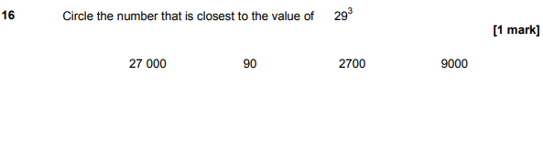
AQA GSCE – Tuesday 6 November 2018 – Paper 1 (Non - Calculator) Higher Tier
25.
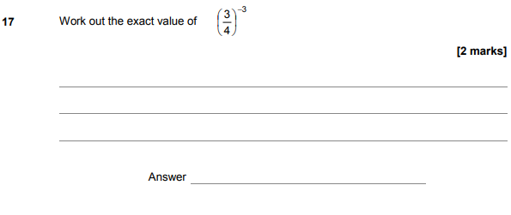

AQA GSCE – Monday 24 May 2018 – Paper 1 (Non - Calculator) Higher Tier
26.
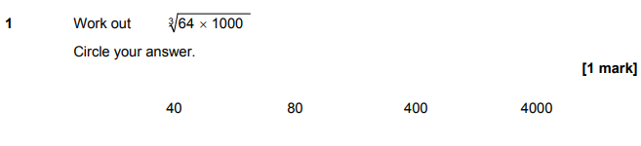
AQA GSCE – Thursday 2 November 2017 – Paper 1 (Non - Calculator) Higher Tier
27.
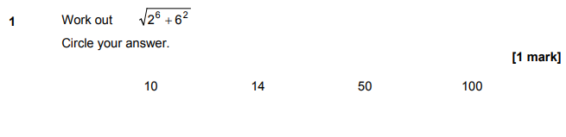
AQA GSCE – Thursday 2 November 2017 – Paper 1 (Non - Calculator) Higher Tier
28.
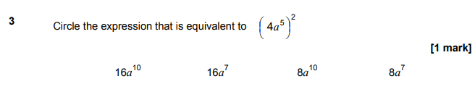

AQA GSCE – Wednesday 8 November 2017 – Paper 3 (Calculator) Higher Tier
29.
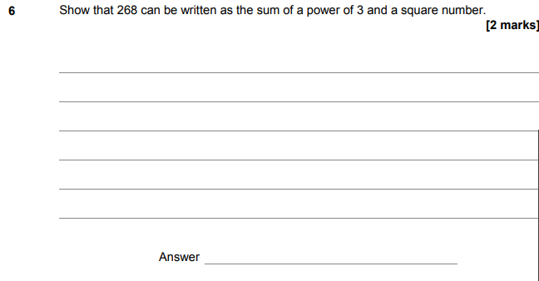
AQA GSCE – Tuesday 13 June 2017 – Paper 3 (Calculator) Higher Tier
30.
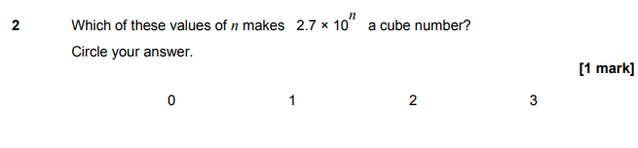
AQA GSCE – Sample Paper 1 (Non - Calculator) Higher Tier
31.
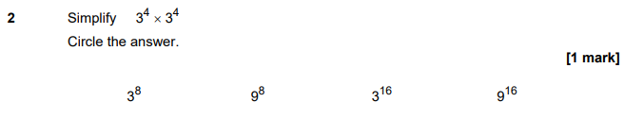

AQA GSCE – Sample Paper 3 (Calculator) Higher Tier
32.
